Project Documentation
Streamlining IT Procurement: Automating Standard Laptop Orders with Flow Designer

1. Introduction
Item | Details
Project Title | Streamlining IT Procurement: Automating Standard Laptop Orders with Flow Designer
Team ID | MKU201Team76ab4df35a238dc999eb5e6de
Date | 30 September 2026
Platform | ServiceNow (Flow Designer / Workflow Studio, Service Catalog)

Team Members
S.No | Team Member | Role
1 | Mohamed Aahin | Flow
2 | Thirupathi | Flow assignment
3 | Janarathanan | Service catalog
4 | RohithKanna | Conclusion
5 | Vivekanathanan | Conclusion

2. Project Overview

Purpose
The current IT procurement process lacks efficiency and automation, resulting in delays and manual effort, particularly in handling standard laptop orders. Standard laptop requests require configuration, but this step may be overlooked or delayed, causing user inconvenience and inefficient resource utilisation within the IT department.
User story: As a member of the IT procurement team, I want a streamlined process for ordering standard laptops so that configuration tasks are automatically created and assigned to the Hardware team. This ensures that laptops are configured promptly upon arrival, reducing user wait times and minimising manual intervention.
Objective: Implement an automated workflow using Flow Designer to facilitate the procurement and configuration of standard laptops, so that the project:
- Ensures a seamless experience for users requesting standard laptops through timely configuration.
- Reduces manual intervention and potential errors in the procurement process.
- Improves resource utilisation through efficient task assignment.
- Enhances overall efficiency and productivity in IT procurement operations.

Features
- A Flow Designer flow named “Standard Laptop Task”, triggered by the Service Catalog.
- Automatic creation of a Catalog Task for every Standard Laptop order.
- Automatic assignment of the task to the Hardware group, with the short description and description “Laptop need to be Configured”.
- Task approval value set to Approved, so the task is ready for action once the request is approved.
- The flow is attached to the Standard Laptop catalog item through its Process Engine settings.

3. Architecture
This project is built on the ServiceNow low-code platform, so it does not use a separate React, Node.js or MongoDB stack. The three layers of the requested format map to the following platform components.

Frontend
The user-facing layer is the standard ServiceNow UI. Users browse the Service Catalog, open Hardware > Standard Laptop and place the order with Order Now. The flow itself is designed in Workflow Studio (Flow Designer). No custom front-end code was written.

Backend
The backend logic is the Flow Designer flow Standard Laptop Task (application scope: Global, Run As: System User):
- Trigger: Service Catalog.
- Action 1: Create Catalog Task, with the requested item record from the trigger mapped to the Requested Item field.
- The flow is saved and activated, then attached to the Standard Laptop catalog item (Process Engine > Flow).

Database
Data is stored in standard ServiceNow tables; no new tables or custom schema were created.
Record | Table / Number format | Role in this project
Request | REQ… | Created when the laptop is ordered; contains the Approvers section used to approve the request.
Requested Item | sc_req_item (RITM…) | The Standard Laptop item within the request; its stage moves to Request Approved.
Catalog Task | sc_task (SCTASK…) | Configuration task created by the flow and assigned to the Hardware group.

4. Setup Instructions

Prerequisites
- A ServiceNow instance (for example a personal developer instance) and a web browser.
- A user with administrator access (the project was built as System Administrator).
- Access to Flow Designer / Workflow Studio and to Maintain Items in the Service Catalog.
- The Standard Laptop catalog item (category Hardware, catalog Service Catalog) and a Hardware assignment group.

Installation
There is nothing to clone or install; the solution is configured inside the instance.
Milestone 1: Create the flow
- Open ServiceNow and access Flow Designer.
- Create a new flow named “Standard Laptop Task”, select Global as the application and System User as the Run As option.
- Add Service Catalog as the trigger.
- Add the Create Catalog Task action and map the Requested Item Record to the Request Item field.
- Set the Short Description to “Laptop need to be Configured” and use the same text in the Description field.
- Assign the task to the Hardware group and set Approval to Approved.
- Save and Activate the flow.
Milestone 2: Assign the flow to the catalog item
- Navigate to Maintain Items, then search for and select the Standard Laptop catalog item.
- Open the Process Engine section and remove the existing automation configurations.
- Select Flow as the process option and add the “Standard Laptop Task” flow.
- Save the catalog item configuration.

5. Folder Structure
ServiceNow does not use client and server folders. The solution is organised as platform records inside the Global application scope.

Client
No custom client code. The user interface consists of the Service Catalog item form (Hardware > Standard Laptop) and the standard Request, Requested Item and Catalog Task forms.

Server
Component | Organisation
Flow: Standard Laptop Task | Global scope; trigger Service Catalog; one action (Create Catalog Task).
Catalog item: Standard Laptop | Catalog: Service Catalog; Category: Hardware; Process Engine set to the flow above.
Assignment group: Hardware | Receives the generated configuration tasks.

6. Running the Application
There are no npm commands for this project. Once the flow is active and attached to the catalog item, it runs automatically whenever a Standard Laptop is ordered. To run and verify it:
- Open the Service Catalog from the All menu.
- Go to Hardware, select Standard Laptop and click Order Now.
- Check the Order Status and open the generated Request Number.
- In the request record, open the Approvers section and approve the request with the Approve option.
- Open the associated Requested Item record and go to the Catalog Tasks section.
- Verify that the task was created with the updated Short Description and Assignment Group.

7. API Documentation
No custom REST endpoints were created. The automation is event-driven: the Service Catalog trigger starts the flow and the flow creates the task. The data used by the flow is summarised below.

Trigger: Service Catalog (outputs)
Output | Type | Use
Requested Item Record | Record | Mapped to the Requested Item field of the new task.
Table Name | Table Name | Table on which the trigger fired.
Run Start Time UTC / Run Start Date/Time | Date/Time | Execution start information.

Action: Create Catalog Task
Input | Value
Table Name | Catalog Task [sc_task]
Requested Item | Requested Item Record from the trigger
Short Description | Laptop need to be Configured
Description | Laptop need to be Configured
Assignment group | Hardware
Approval | Approved

Output | Type | Example
Catalog Task | Record | SCTASK0010002, linked to RITM0010002
Action Status | Object | Status of the action run

8. Authentication
Authentication and authorisation are handled by ServiceNow itself; no custom tokens or session logic were added.
- Users sign in to the ServiceNow instance with their own credentials and use the platform session.
- The flow executes as System User (Run As), so task creation does not depend on the ordering user’s permissions.
- Authorisation for the order is the approval step: the request must be approved from the Approvers section.
- Flow and catalog item configuration requires administrator access.

9. User Interface
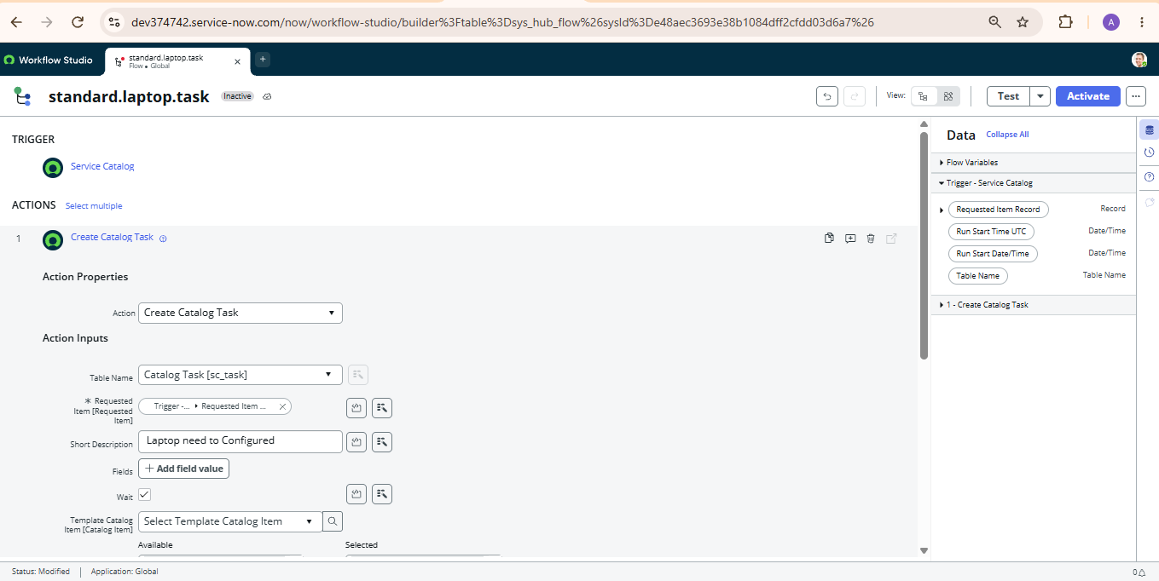
Figure 1: Standard Laptop Task flow with the Service Catalog trigger and Create Catalog Task action
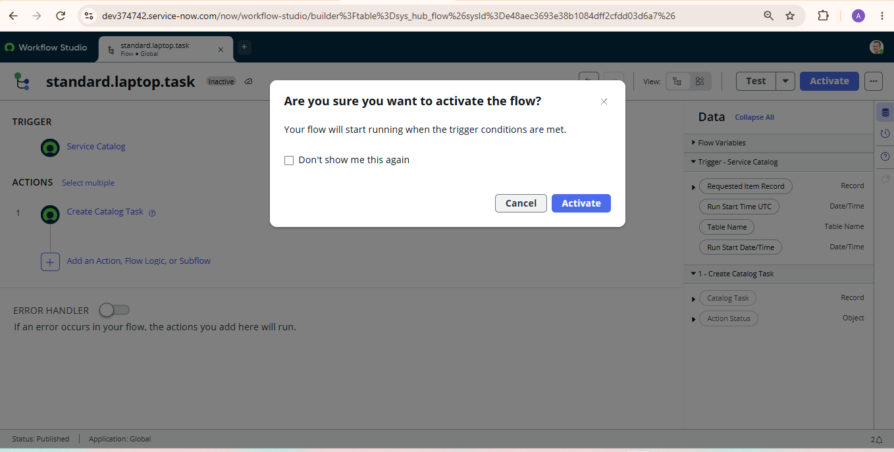
Figure 2: Activation confirmation for the flow
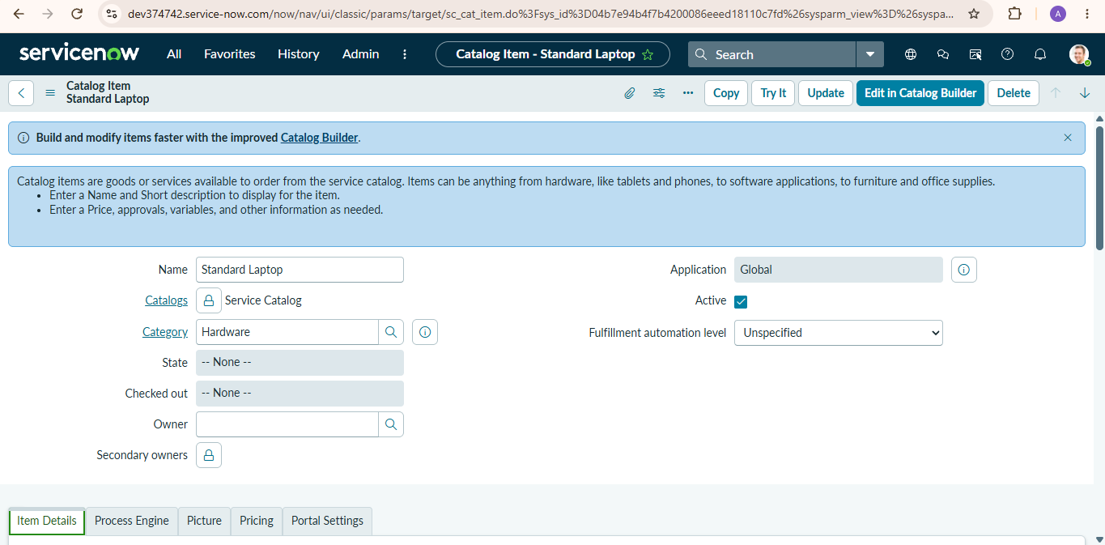
Figure 3: Standard Laptop catalog item (Service Catalog, Hardware category)

10. Testing
Testing was manual, performed end to end in the ServiceNow instance by following the milestone steps and checking the resulting records. The results are recorded in the UAT Execution & Report Submission document.
Test area | Total | Fail | Not tested | Pass
Flow creation (Milestone 1) | 12 | 0 | 0 | 12
Flow assignment (Milestone 2) | 7 | 0 | 0 | 7
Service catalog order placement | 4 | 0 | 0 | 4
Request approval | 2 | 0 | 0 | 2
Catalog task verification | 3 | 0 | 0 | 3

Result: the request was approved, the Requested Item reached the stage Request Approved, and a Catalog Task with the expected short description and description was created.

11. Screenshots or Demo
The screenshots below show the final result of placing a Standard Laptop order. No video demo link is available.
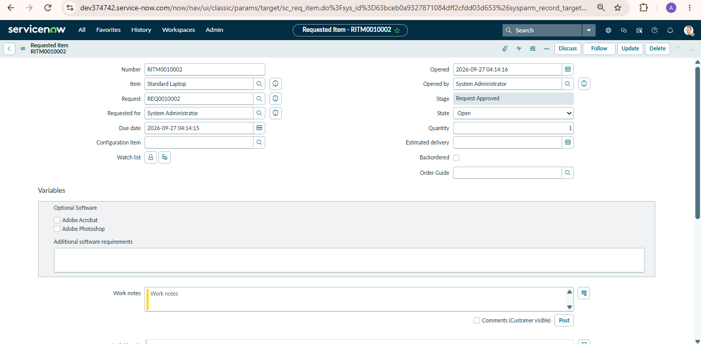
Figure 4: Requested Item RITM0010002 (Standard Laptop), stage Request Approved
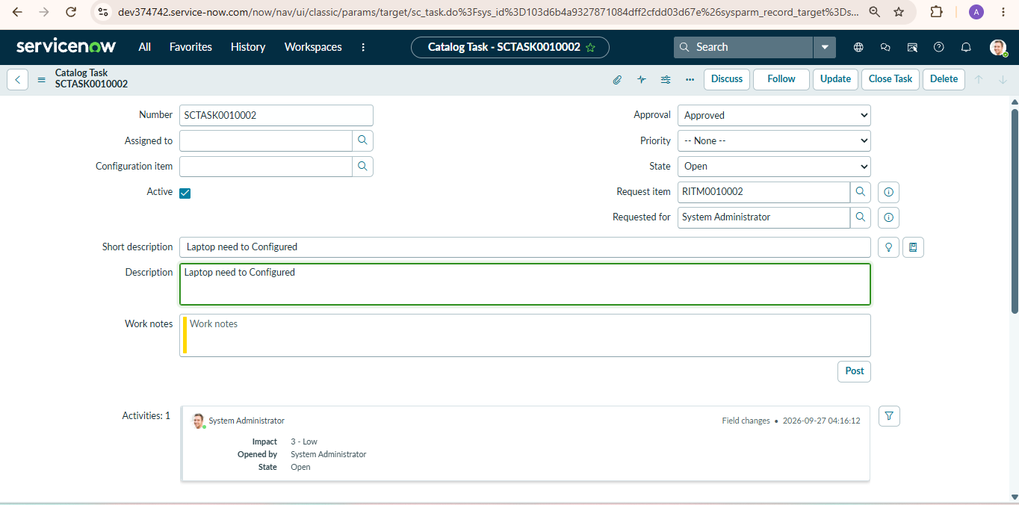
Figure 5: Catalog Task SCTASK0010002 created by the flow for RITM0010002

12. Known Issues
No functional defects were recorded during UAT. The following minor points were noticed:
- The task text in the created record reads “Laptop need to Configured”, while the documented wording is “Laptop need to be Configured”.
- The created Catalog Task has the Assigned to field empty; it is routed to the Hardware group, and an individual must pick it up.
- The Standard Laptop catalog item shows Fulfillment automation level as “Unspecified”.

13. Future Enhancements
- Correct the task wording and keep it consistent between the flow and the documentation.
- Send email notifications to the Hardware team when a task is created and to the requester when the laptop is configured.
- Assign tasks to individual technicians automatically (for example by workload or round robin).
- Extend the same pattern to other hardware items such as monitors and docking stations.
- Add due dates or SLAs for configuration tasks and a dashboard reporting on procurement turnaround time.

